* **Lab Task 4:**

### Find the Difference Between the Highest and Lowest Ticket Prices

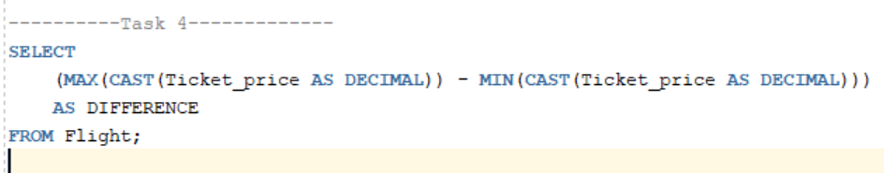

Output:

